Milestone 3: Camera Parameter Estimation and Point Cloud Generation
Wei-Yuan Su, Kehao Xu
https://github.com/Wayne0758/Computer-Vision

This report presents the results of sparse 3D reconstruction using pycolmap. We reconstructed a 3D model of Kavli Hall using a dataset of 428 images. The goal was to evaluate the performance of different feature extractors and matchers—SuperPoint+SuperGlue and SIFT+NN-ratio, in terms of reconstruction quality, robustness, and optimization behavior.
- Effect of Different Feature Matchers and RANSAC Parameters
We evaluated the effects of SuperPoint+SuperGlue and SIFT+NN-ratio for feature extraction and matching on the Kavli Dataset. SuperPoint+SuperGlue provided more matches with more details in the textured regions, while SIFT+NN-ratio provided less matches which is hard to build a complete 3D model.
RANSAC is included by function “reconstruction.main” and its threshold is set by default to 4 pixels. Theoretically, A lower inlier threshold improved precision but reduced the number of 3D points, especially with noisy matches. A more relaxed threshold led to denser reconstructions at the cost of higher outlier rates.

- Observations on the Bundle Adjustment Process
Table1: Results of SuperPoint+SuperGlue and SIFT+NN-ratio
Extractor+Matcher | SuperPoint+SuperGlue | SIFT+NN-ratio
num_reg_images | 104 | 211
num_points3D | 46742 | 23262
mean_track_length | 4.36 | 4.48
mean_observations_per_image | 1950.12 | 493.67
mean_reprojection_error | 1.46px | 1.33px
The table1 shows the reconstruction results of two methods
SuperPoint+SuperGlue:
- Mean track length of 4.36 suggests each 3D point was observed in multiple views, contributing to stable triangulation.
- The mean reprojection error after optimization was 1.46 pixels, indicating good alignment between projected and observed keypoints.
SIFT+NN-ratio:
- Mean track length of 4.48 indicates that each 3D point was generally observed across multiple views, contributing to stable triangulation.
- The mean reprojection error after optimization was 1.33 pixels, suggesting that the retained matches were geometrically consistent.
Observation:
- SuperPoint+SuperGlue produced a significantly denser reconstruction due to a higher number of observations per image, enabling more complete scene coverage.
- SIFT+NN-ratio resulted in a lower mean reprojection error, indicating higher geometric precision, but at the cost of reduced point cloud density and completeness.
- Bundle adjustment helped suppress spurious points and refine both point locations and camera poses.
- Visualizations and Reconstruction Highlights
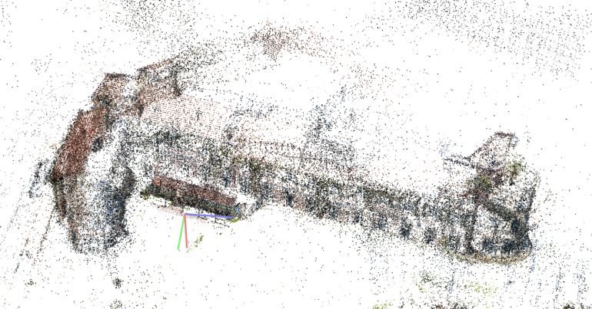
Picture1: 3D Sparse Point of SuperPoint+SuperGlue

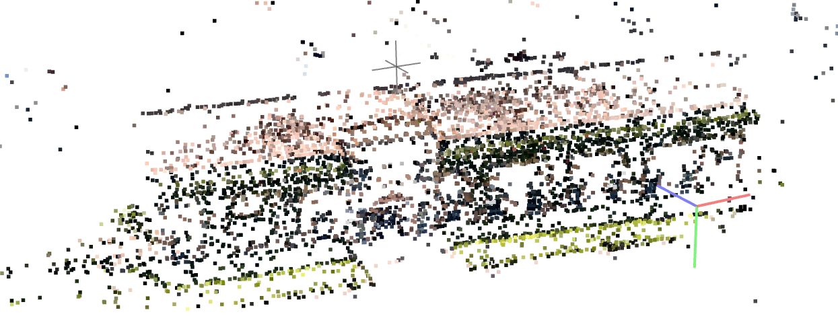
Picture2: 3D Sparse Point of SIFT+NN-ratio
Based on the images above, we observe that different methods reconstruct the model from different perspectives. The SuperPoint+SuperGlue combination produces significantly more and denser feature points, while SIFT+NN-ratio yields fewer matches. Overall, SuperPoint+SuperGlue demonstrates superior performance. However, in Picture 1, a small building—actually the front entrance of Kavli—appears incorrectly, as it should not be visible from this angle. This error becomes more apparent upon zooming in, as shown in Picture 3.
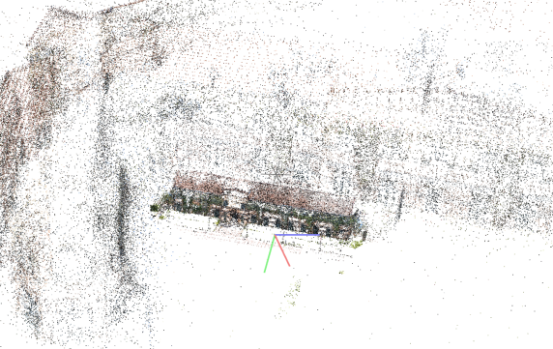
Picture3: Errors of SuperPoint+SuperGlue
The dense point cloud provides photorealistic scene geometry, as shown in the picture4, suitable for detailed visualization and 3D modeling. Fine textures, such as vines on the building and shadows under awnings, are accurately captured.
The transition from sparse to dense significantly enhances the visual interpretability and realism of the reconstructed scene.
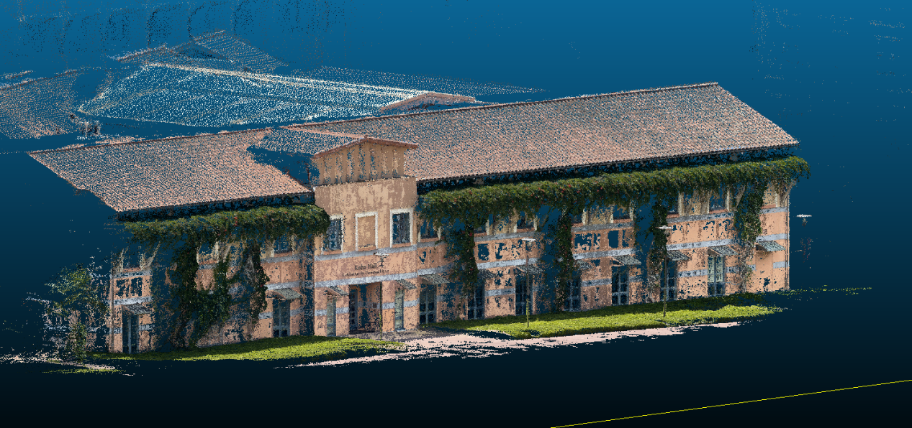
Picture4: 3D Dense Point Cloud
Conclusion:
While the sparse point cloud forms the geometric and structural backbone of the reconstruction pipeline, the dense point cloud enhances perceptual detail and is indispensable for applications in 3D visualization and AR/VR. Together, they offer a comprehensive pipeline from structure inference to high-fidelity rendering.

